**DAA ASSIGNMENT 1**

**Aim:**

To understand the rules and grading policies outlined in the UG program rule book and learn the process of calculating **Semester Performance Index (SPI)** and **Cumulative Performance Index (CPI)**. Additionally, to develop an algorithm and implement a C++ program that calculates SPI and CPI based on student grades and credits.

1. Algorithm and test cases:

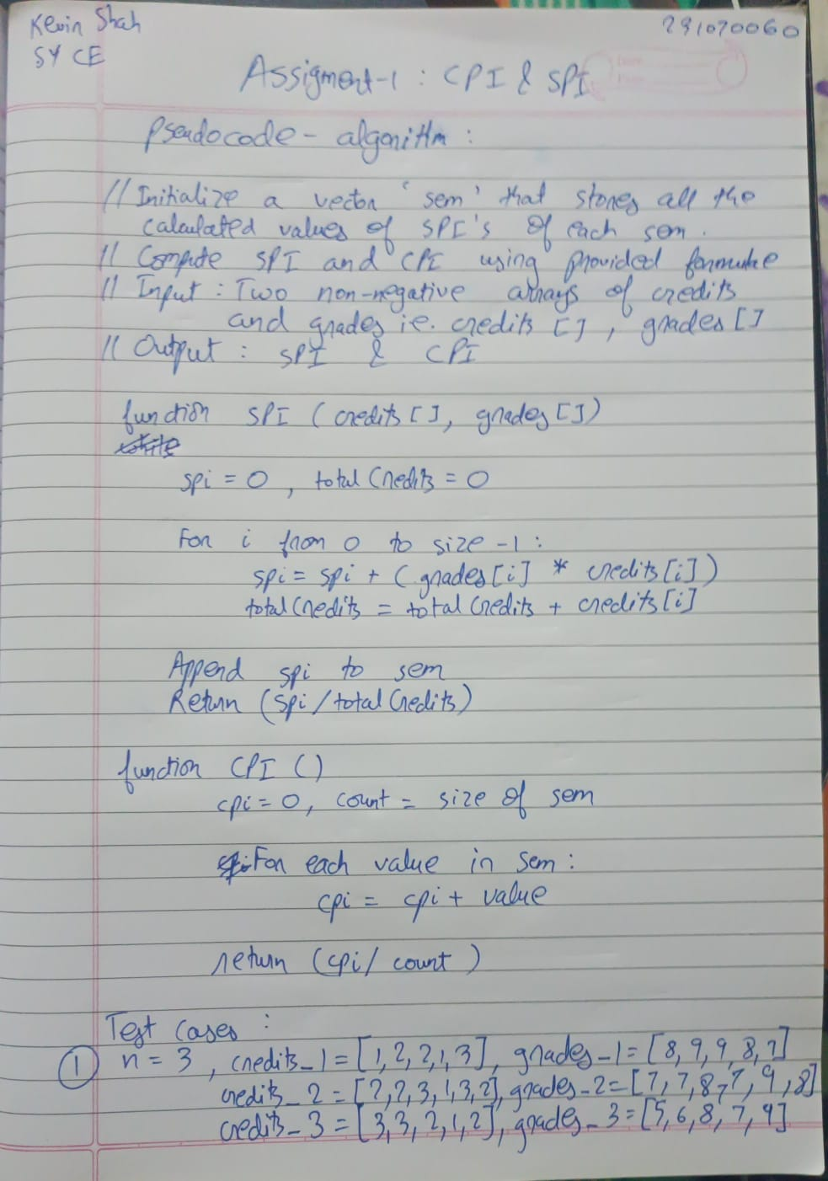

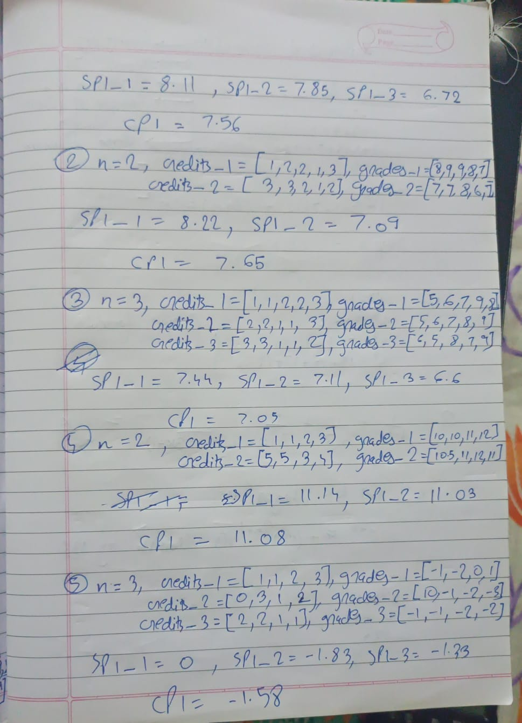

3. Program

a)SPI

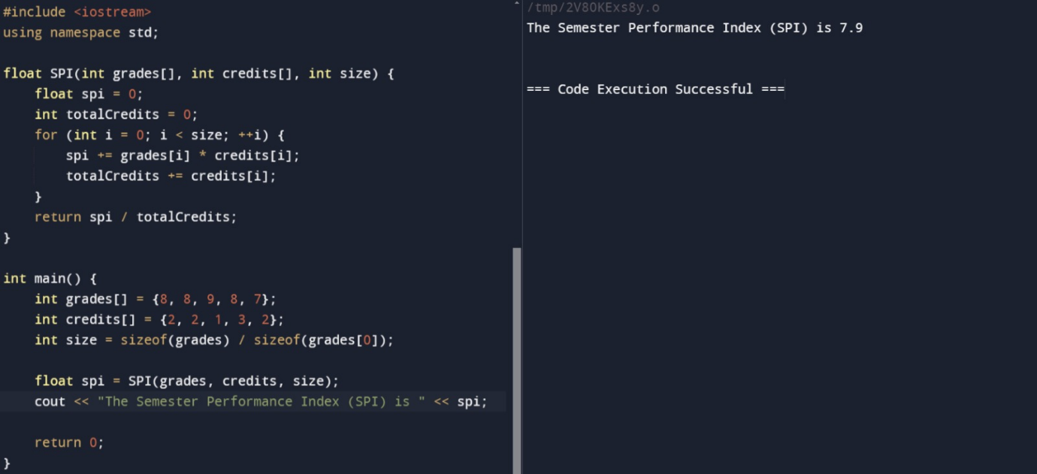

b)CPI

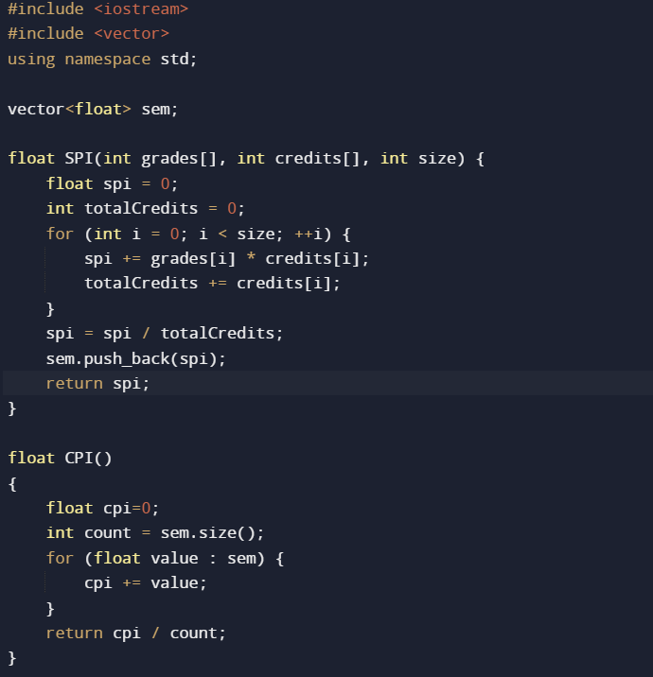

Followed by main() which is similar to that of SPI

4. Test the program for the above test cases

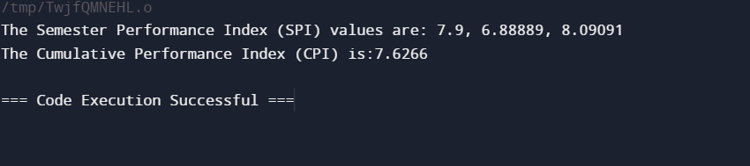

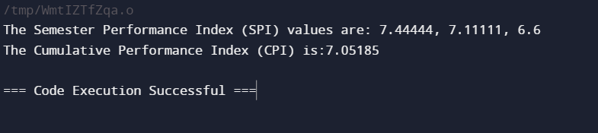

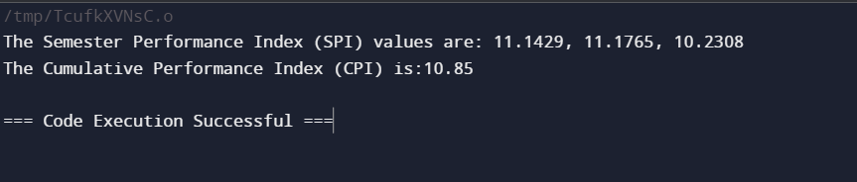

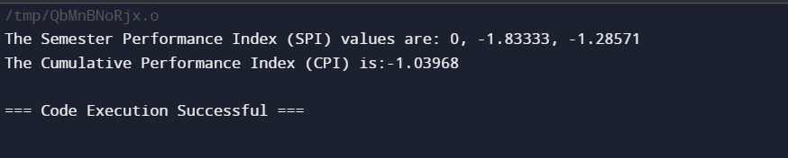

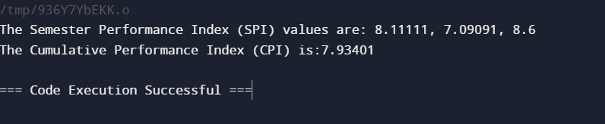

**Conclusion:**

In this exercise, we successfully familiarized ourselves with the grading policies outlined in the UG program rule book and gained a comprehensive understanding of the process for calculating the **Semester Performance Index (SPI)** and **Cumulative Performance Index (CPI)**. We analyzed the formulae and rules applied in real-world scenarios and developed a structured algorithm to represent the step-by-step process for determining these performance metrics.

The implementation of this algorithm in C++ provided a practical way to automate the calculation of SPI and CPI based on student grades and corresponding course credits. By testing the program with sample data, we verified its accuracy and efficiency in computing the performance indices. This automated approach ensures a consistent and error-free evaluation of academic progress, offering a reliable tool for students to track their semester-wise and overall academic performance. Additionally, it aids educators in making data-driven assessments and decisions regarding student achievements. Overall, the exercise reinforced the importance of understanding grading systems and demonstrated the application of programming in solving real-life academic problems.